The idea behind the Twincat code:

I imagine there are 2 kitchen robots responsible for making a mix of meat and greens. One of the robots will cut and spice them, and the other will cook and plate them. The robots themselves know how to do these things but not when or if they need to continue or not. The code in twincat is a small piece of the communication between these robots.
The robots communicate Through the GVL_Kitchen, the one responsible for cooking and plating is called “Burner” and the one responsible for cutting and spicing is called “Cutter”.

Below the Plantuml diagram can be found
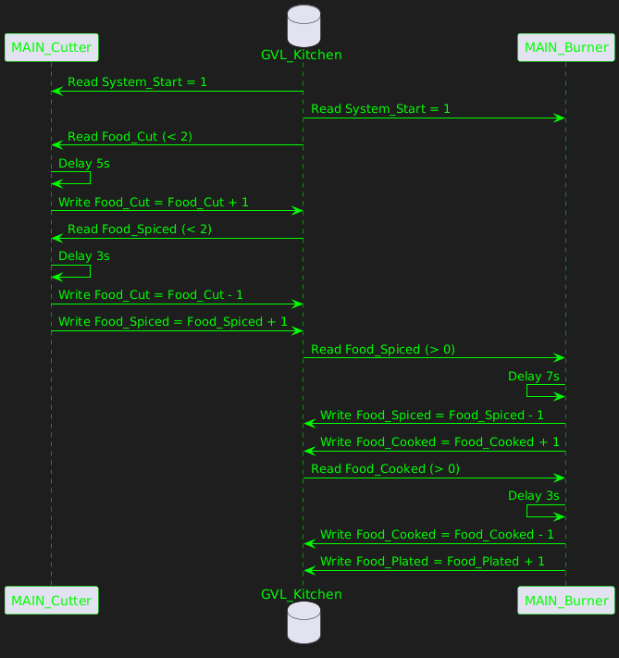
As seen in the above image the Cutter robot will check if there is any Food_Cut left and then start cutting these. Afterwards it will check if there is any food that needs to be spiced, it will read Food_Spiced from the GVL_Kitchen and depending on how many are left, will start spicing them. If there are 2 or more Food_Cut or Food_Spiced the machine will wait until the “burner” takes some Food_Spiced from the GVL.

The Burner robot will read the Food_Spiced from the Cutter robot and cook them into Food_Cooked. It does this by writing Food_spiced -1 and Food_Cooked+1 to the GVL_Kitchen. Afterwards it will reads if there are food_Cooked and write them into Food_Plated which is the end product.

The delays in the program represent the cutter and burner robot performing their tasks.

